Elementary French
Course Description
An introductory study of the culture, language, grammar, and vocabulary of French and the francophone world by means of reading, writing, speaking, listening, and authentic language experiences.
Boy, those French! They have a different word for everything. – Steve Martin

course # MLA1019-1 SP15
credit hours: 3
location: CAMP304
time: MTWRF 5:30p-6:10p
instructor(s): Matt Price
Contact:
Office: Campus Center
School of Theology
Hours MF 1:00-2:00/TR 9:00-10:00
Phone: ext. 3617/Cell 740-504-3325
Web: www.professorprice.net
Email Matt.Price@mvnu.edu
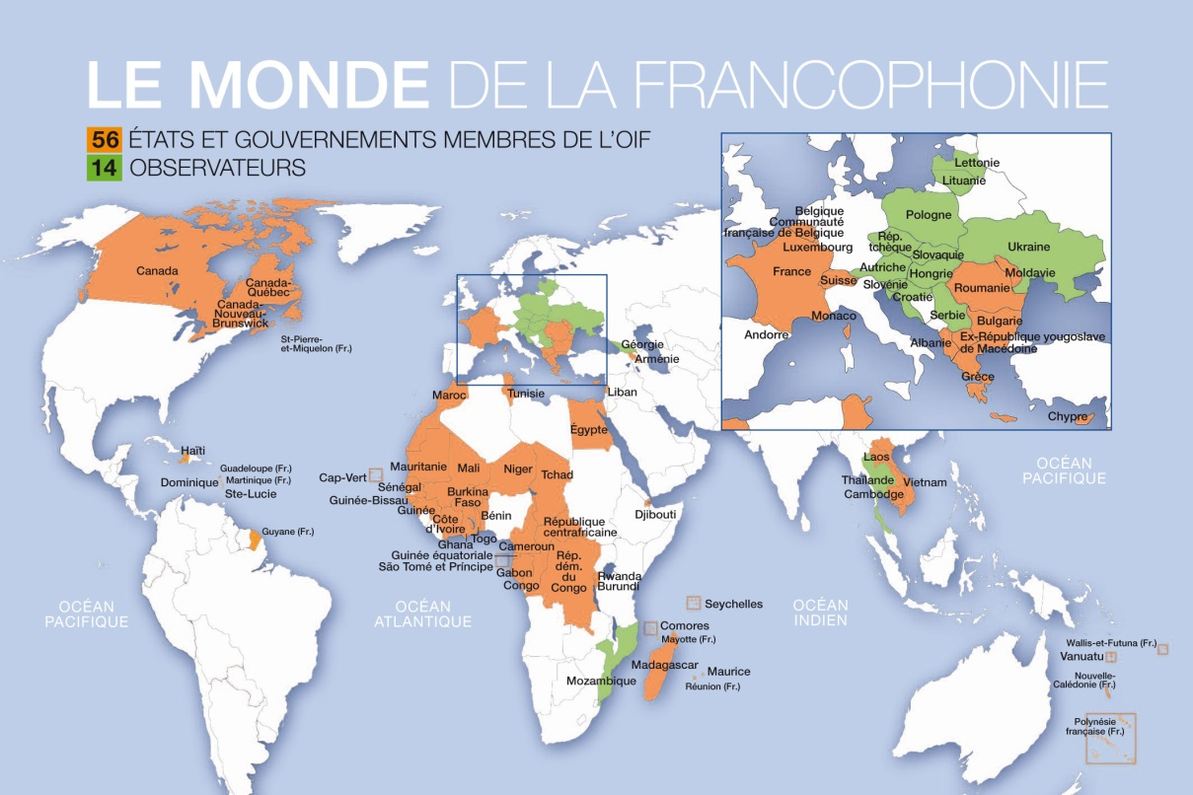
L’Organisation internationale de la francophonie
Source: robertbaxter.org 2008
Course Textbooks (required) | Bulgar, Anthony. 2008.l New French with Ease (Assimil Method Book and CD edition). Assimil Gmbh.  Crocker, Mary. 2013. Schaum’s Outline of French Grammar. Sixth edition. McGraw-Hill.  Kendris, Christopher & Kendris, Theodore. 2013. Pronounce It Perfectly in French with Audio CDs. Third edition. Barron’s Educational Series.  Not Required But Helpful:  Wyner, Gabriel. 2014. Fluent Forever: How to Learn Any Language Fast and Never Forget It. Harmony Books.  Anki app
How to Get an “A” This Semester
Daily Commitment. This three-credit hour course meets five days a week for 40 minutes at a time. Attendance & participation is one-third of your final grade. | Inside Class. We will focus on oral practice and written revision in class. It will also be a time in which to interact with francophone speakers from around the world and test our outside learning. | Outside Class. Most of your learning will take place outside of class using the required and suggested toolkits. Plan on one hour a day except Sundays.

 | Course Outcomes
Formative Assessments | By the end of the semester, students will be able to: | Summative Assessments
Assistance (Attendance)  Attendance is translated as l’assistance in French. And, it’s true, participation in class will assist your grade. In fact, participation will be 33% of your final grade. And, big points will be deducted for absences (excused or unexcused). Being here is important, but so is being ready—always bring your textbooks and materials for taking notes. No computers or phones allowed. You need to place your phone/device on my desk before taking a seat. We have 40 minutes and will use all of them. (C1, C2)  Devoirs (Homework Submissions)  Schaum’s Grammar will be used for almost all of the homework assignments. There is a response key at the end of the text. You will need to complete the exercises in black ink, and then correct them in red ink after looking at the response key. If the exercise number is even do even-numbered items, odd exercises then do the odd numbered items (exercise #6 do items 2, 4, 6, etc) All written homework assignments will be handwritten and in ink. (C3, C4)  Dictées (Oral and Written Diction)  There will be an occasional dictéé, a short but precise test of the ability to hear and write in French which are typical in francophone cultures. They are sticklers for well written and precise use of language. The dictées will usually be conducted in class. There are no make-up opportunities due to absence. (C3, C4)  Révisions (Quizzes)  There will be weekly quizzes (known as révisions in French) on previous material covered taking place every Friday. Vocabulary is the primary element, but grammatical and cultural items might also appear. (C4, C5)  Soirées Culturelles  (Cultural Get-togethers)  There will be a few activities involving French culture centered on food and film. You must attend at least one of them. Sign-ups will be in class. (C1, C4) | Based upon the National Standards for Foreign Language Learning, the course objectives are centered around the 5Cs (Communication, Cultures, Communities, Comparisons, and Connections). These outcomes will be contextualized to the francophone world.  C1 Interpersonal Communication: Communicate and exchange information about familiar topics. Handle short social interactions in everyday situations by asking and answering simple questions and through brief statements.  C2 Presentational Speaking: Present basic information on familiar topics using language practiced in class using phrases and simple sentences.  C3 Presentational Writing: Write briefly about familiar situations related to francophone contexts highlighting comparisons with the United States as well as to present information using a series of simple sentences.  C4 Interpretive Listening: Understand words, phrases, and simple sentences related to everyday life and culture of francophone contexts. Recognize pieces of information and figure out the main topic of what is being said.  C5 Interpretive Reading: Understand the main idea of short and simple texts when the topic is familiar as well as highlighting connections to francophone history and culture. | Midterm Exam  There will be a midterm exam on material covered up to this point (vocabulary, grammar, written/oral, culture) on the Wednesday before Spring Break. We will go over the exam on Thursday. No class on Friday before Spring Break.  Final Exam  There will be a final exam on the last Monday of the semester at 6:00 p.m.-8:00 p.m. You will have time for dinner before taking the exam. If you have schedule conflict with honors, please set up a time to take the exam in the professor’s office.  N.B.  ASSIMIL French with Ease is the basis for the course structure. It is important to keep up with the ASSIMIL lessons for each day. Instructions for using ASSIMIL are found at the end of the syllabus.  Key Points on This Page:  -Attendance is essential.  -No computers or phones in class.  -Read sections of Schaum’s Grammar (Crocker) related to homework prior to class  -Create flash cards at least once per week  -Review flash cards daily just before or after class  --Keep track of all assignments  --All spelling and grammar mistakes will remove a point from any assignment or quiz. It is possible to get negative points for an assignment.

Course Evaluation | Course Policies
Assignments Points Learning Hours  Attendance (absences automatic 50 pts deduction for each absence) / 7 pts per session 294 42  Devoirs (50 x 2pts) 100 50  Quizzes (12 x 20pts) 240 12  Dictéés (4 x 20pts) 80 2  Midterm Exam 125 10  Final Exam 125 10  ASSIMIL completion (all lessons) Pass/Fail 6  Soirées (2 x 18 pts) 36 4  Total 1000 136  Grading scale is:  A 1000-930 B 879-830 C 749-720 F 599>  A- 929-900 B- 829-800 C- 719-700  B+ 899-880 C+ 799-750 D 699-600  One course learning hour equals . . .  - 10-15 pages of reading (1000 level) (300 page book = 30 learning hours)  - 15 pages of reading (2000 level) (300 page book = 20 learning hours)  - 15-20 pages of reading (3000 level) (300 page book = 15-20 learning hrs)  - 20-25 pages of reading (4000 level) (300 page book = 15 learning hours)  - 2 pages of writing (500 words) (add one hour of research for every research page written, no extra hours added for reflection papers)  - 1 minute of video  - 3 minutes of presentation with visual aids (Powerpoint, Prezi, object lesson, skit, illustration, dialogue, etc.)  - 60 minutes of class time or  - 60 minutes of research  - 60 minutes of exam time  All scheduled time spent in seminars/conferences/field trips (e.g. LEAP seminar should be added into total course work hours) excluding travel | Attendance Policy  Regular attendance and participation is expected. You will lose 50 points for every unexcused absence (excuse only considered if instructor is informed prior to class time). You have an attendance “buffer” of one day.  Sleeping, texting, surfing the internet, & excessive talking could be counted as an absence by instructor’s discretion. The MVNU policy on class attendance provides excused absences for these reasons:  1) participation in official | university organizations (e.g. sports teams) and pre-arranged course trips;  2) severe emergencies or death in the immediate family;  3) legal responsibilities; or  4) extended personal illness when an authorized medical official requires confinement to home, room, or hospital.  (NOTE: The following are not excused absences: Weddings, birthdays, school functions, holiday celebrations, work obligations, volunteer work, job interviews, hospital visits, feeling sick or tired). | Assignment Submissions  Assignments are due on the due date at class time. No exceptions. Nothing accepted by email, either. Standard submission will be paper copy in class and/or to Moodle (TurnItIn) unless otherwise noted.  Handwritten for this class only.  Accommodation  See the instructor if you need accommodations, as defined by the Americans with Disabilities Act of 1990, and then follow the Disability Services Policies and Procedures as put forth by the office of Academic Success office or search for page on the MVNU web site. Instructors are generally able to accommodate as needed.
Grading Rubric  A—Being present in class, engaging in activities, turning in homework on time without error, doing well on quizzes  B – Being present and occasionally engaged, turning in homework with some errors, doing sufficient on quizzes  C—Being present in class with a couple of absences, turning in some of the homework, surviving quizzes  D—Missing class more than three times, turning in some assignments, not doing well on quizzes | Academic Integrity  MVNU seeks learners committed to honesty among students, faculty, and staff, a standard governing expectations for all campus and educational activities. As a Christian community, there is a moral and ethical responsibility to uphold this standard as found in the Academic Catalog (for examples of violations). All course work submitted to instructor(s) should be evidence of personal learning endeavors.

Course Schedule—MLA1019-1—SPRING 2015 (MTWRF)
Subject to change in terms of topic and assignments
Week | ASSIMIL | Schaum’s Outlines in French Grammar | Barron’s Pronounce It Perfectly in French | Vocabulary (Web) | Culture Moments (Wednesday)
Wk1 | 1-7 | Articles (Schaum pp 1-2, 9-21)  Interrogative adverbs & expressions (Schaum pp 235-238)  (être/avoir, -er verbs) (Schaum pp 124-126, 100-107) | Barron’s Intro & Lesson 1-Lesson 3e; CD1Tk1-17 | Le temps  Les saisions  Les jours | La Semeuse/Academie Francaise/Alliance Francaise
Wk2 | 8-14 | Nouns (Schaum pp 1-9) (additional pages on Moodle)  Numbers, Dates, Time (Schaum pp 88-97)  (aller, voir) (Schaum pp 118-119, 126) | Barron’s Vowels: Lesson 3i to 5, CD2Tr1-18) | La famille
Wk3 | 15-21 | Adjectives (Schaum pp 24-41)  Adverbs (Schaum pp 41-47)  Comparisons, Superlatives, Pronouns: Possessive, Disjunctive (Schaum pp 47-56, 266-268)  (pouvoir/vouloir, -ir verbs) (Schaum pp. 107-109, 122-123) | Barron’s Consonants: Lessons 6-8; CD2Tk19-21 & CD3Tk1-5 | La maison  Le salon  Les toilettes | Gaulois:  Asterix to Charlie Hebdo
Wk4 | 22-28 | Pronouns: Demonstrative, Indefinite (Schaum pp 56-61, 270-271)  Prepositions (Schaum pp 70-85)  (faire, -re verbs) (Schaum pp 109-110, p. 127) | Barron’s Word Patterns & Intonation: Lessons 9-11; CD3Tk6-9) | L’hiver  Le jardin | Monasteries/Cathedrals (Tamié, Notre Dame, Taizé)
Wk5 | 29-35 | CAPERED (verbs without prepositions)  Reflexive/Pronominal Verbs (Schaum pp 132-140, 265)  Negation (Schaum pp 242-250)  Pronouns: quelque, tout (Schaum pp 61-65) | Barron’s More Practice in Context: Lessons 12-19; CD3Tk10-23) | La cuisine  La nourriture | Regional Cuisine (Cheese,Bread, Wine)
Wk6 | 36-42 | Passé composé (Schaum pp 148-156)  MIDTERM
Congés |  | SPRING BREAK  (review at least 15 mins day in ASSIMIL & Barron’s)
Wk7 | 43-49 | Review  Irregular Verbs (Schaum pp 98-131)  Future Tense Verbs & Conjunctions (Schaum pp 173-180) | Barron’s Vowels: Lesson 1-Lesson 3e CD1Tk4-17) | La plage  L’informatique | Royalty, Revolution, Republic (Charlesmagne, Napeleon, Louis XVI, Charles de Gaulle)
Wk8 | 50-56 | Present Participle (Schaum pp. 140-142)  Imperfect Tense Verbs (Schaum pp 142-148)  Interrogative Adjectives (Schaum pp 238-240) | Barron’s Vowels: Lesson 3i to 5, CD2Tr1-18) | La fête religieuse | Cave Paintings, Monet, Van Gogh, Gauguin, Picasso
Wk9 | 57-63 | Pronouns (direct object/indirect object/y/en) (Schaum pp 253-259, 265)  Qui/Que—Interrogative Pronouns (Schaum pp 236-238) | Barron’s Consonants: Lessons 6-8; CD2Tk19-21 & CD3Tk1-5 | Les animaux familiers  Le parc | Quebec & America
Wk10 | 64-70 | Double pronouns (pp 259-264)  Qui/Que—Relative Pronouns (Schaum pp 272-278) | Barron’s Word Patterns & Intonation: Lessons 9-11; CD3Tk6-9; More Practice in Context: Lessons 12-19; CD3Tk10-23) | L’hôpital, le docteur | Francophone Africa
Wk11 | 71-77 | Conditional Verbs, Uses, & Si Clauses (Schaum pp 182-191; 193-195) | Barron’s Vowels: Lesson 1-Lesson 3e CD1Tk4-17) | Le restaurant | Brits & French, Brittany & Normandy (William the Conqueror, Bayeux Tapestry, Omaha Beach)
WK12 | 78-84 | Subjunctive Verbs , Uses, & How to Avoid (Schaum pp 195-213) | Barron’s Vowels: Lesson 3i to 5, CD2Tr1-18) | La Bible  L’école | Le ciné
Wk13 | 85-92 | Compound Tenses (Schaum pp 186-192)  Review: Nouns, Adjectives/Adverbs, Verbs | Barron’s Consonants: Lessons 6-8; CD2Tk19-21 & CD3Tk1-5 | Les pensées  Les sentiments
FINAL | 93-113 | May 11 Monday 18h00-20h00

Programme de classe  (Daily Class Session—40 minutes—17:30-18:10)  17h30 Worship chorus  17h35 Oral repetition with Assimil  17h40 Grammar Lesson with Schaum or Culture Notes  17h55 Written/Oral Practice (Quiz on Friday)  18h10 Questions/Announcements/Submit homework from previous day  N.B. Bring Schaum’s Grammar, ASSIMIL booklet, and Pronounce It Perfectly in French to class each day.  You will also need a pencil, pen with black ink, and pen with red ink. |  | Programme de devoirs quotidiens  60 minutes (lundi à samedi)  (Daily Homework Schedule – 60 minutes – Mon to Sat)  8 minutes – Oral Repetition (ASSIMIL) – listen & respond 3X minimum  5 minutes – Review class notes/Schaum/Assimil – note questions & confusions  15 minutes – Written practice – Schaum/Barron exercises, handwritten, dark ink  (N.B.—Schaum exercise number determines whether to complete odd or even items, e.g. Exercise 38 means do the even items only)  7 minutes – Barron Pronunciation Practice  10 minutes – Review vocabulary on cards (handwritten or Anki app)  15 minutes – Make new cards or read cultural assignment

More Resources:
Alain Le Lait videos (youtube)
Hillsong French Worship (youtube)
Lexilogos.com
Fluent-Forever.com
Ankiweb.net
Other resource links will be added and updated at www.professorprice.net

